Muscles and Joints

**Tendons and Ligaments**

Tendons and ligaments are ______________________________________________________

Explain how tendons are different to ligaments.

_____________________________________________________________________________

_____________________________________________________________________________

**Muscles**

Muscles are able to _____________.

They ______ on the bones they are attached to, causing them to move.

Muscles can only _____, they cannot _________.

Another muscle is needed to return the bone to its original position.

An antagonistic pair of muscles is _________________________________________________

____________________________________________________________________________.

Use the diagrams below to explain how an antagonistic pair of muscles works together to move the arm.

_____________________________________________________________________________

_____________________________________________________________________________

___________________________________________________________________________________________

___________________________________________________________________________________________

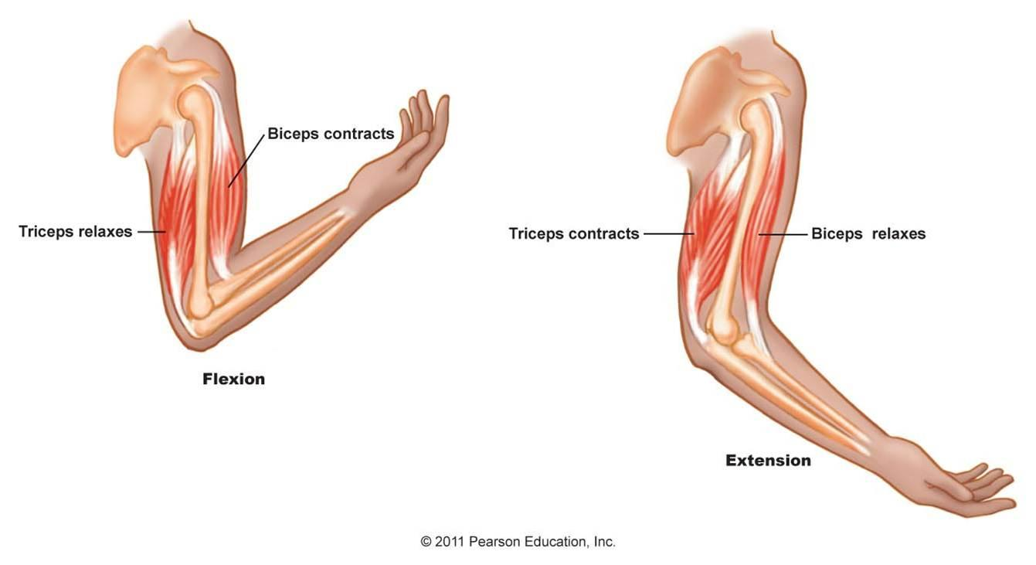



**Joints**

Joints are ____________________________________________________________________.

Cartilage is a __________________________________ on the ends of bones that helps ____________________________________________________________________________.

**Types of Joints**

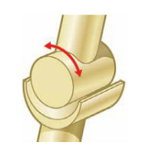**Hinge Joint**

* ________________________________________________________
* ________________________________________________________

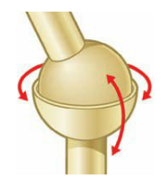**Ball and Socket Joint**

* ________________________________________________________
* ________________________________________________________

________________________________________________________

* ________________________________________________________

**Extension:**

Research pivot and saddle joints. Find out how they move and an example of each in the human body.

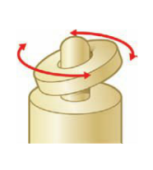**Pivot Joint**

* ________________________________________________________
* ________________________________________________________

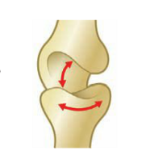**Saddle Joint**

* ________________________________________________________
* ________________________________________________________